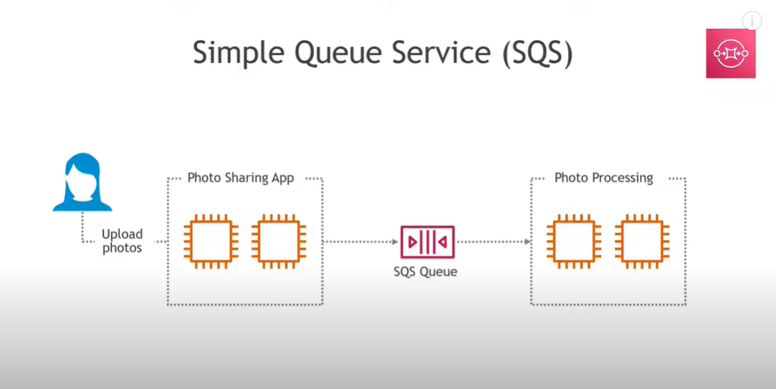

SQS Purpose
Managed message queuing service to decouple and scale microservices.
Amazon MQ Purpose
Managed message broker (RabbitMQ, ActiveMQ) for applications using standard protocols (JMS, AMQP, etc.)
Key Differences
- SQS: Simple, scalable, fully managed, works with AWS native apps.
- Amazon MQ: For existing apps requiring traditional brokers.

Example Task SQS: create a queue and send a message.

Step 1: Create a Queue
- Go to AWS Console → SQS → Create Queue.
- Select Standard Queue (FIFO queues behave slightly differently).
- Give it a name: demo-queue.
- Keep default settings (Visibility Timeout = 30 seconds).
- Click Create Queue.

Step 2: Send a Message
- Open your queue → Click Send and receive messages.
- In the “Message body” type something like:
Hello, this is my first message!

Step 3: Poll for Messages
- In the same screen → Click Poll for messages.
- You’ll see your message appear in the message list.
👉 At this point, the message is NOT deleted. It just became invisible for the Visibility Timeout (30s default).

Step 4: Check Another Tab
- Open the queue in another browser tab.
- Try Poll for messages immediately → You will NOT see the message.
  - That’s because the first tab has a lock on it for 30 seconds.
  - This lock is called Visibility Timeout.

Step 5: Wait or Delete
- If you wait 30 seconds and then poll again → The message will reappear (since it wasn’t deleted).
- If you delete the message from the first tab → It will be removed permanently and won’t show again.
✅ Key Learning:
- Send → Poll → Delete is the full lifecycle.
- If you don’t delete, the message keeps reappearing after timeout.

- 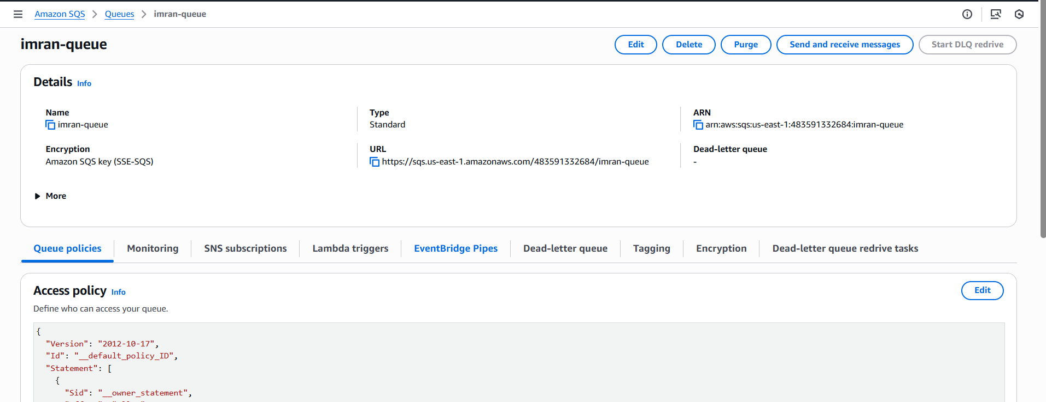
- Send message
- 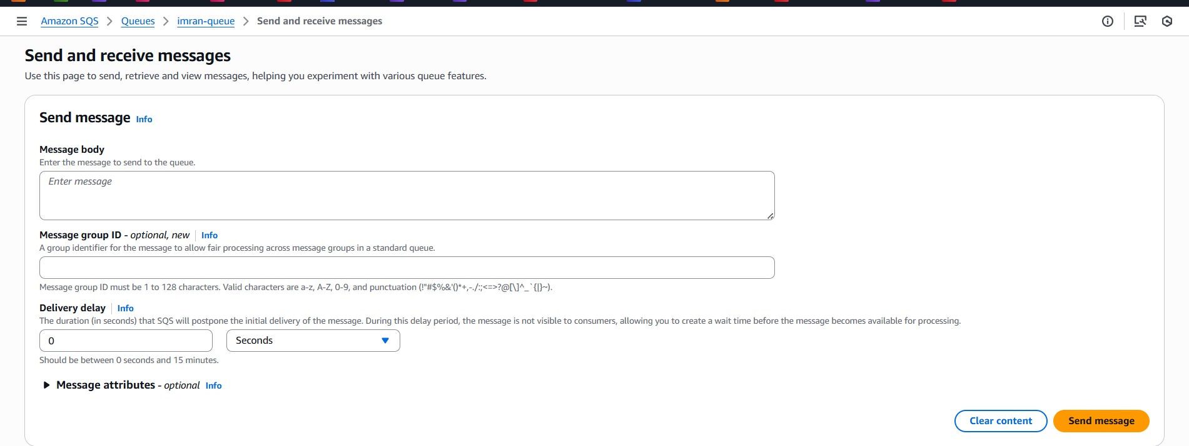
- Poll for messages
- 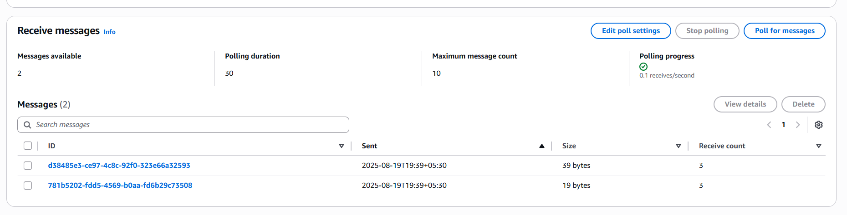
- Check in another tab
- 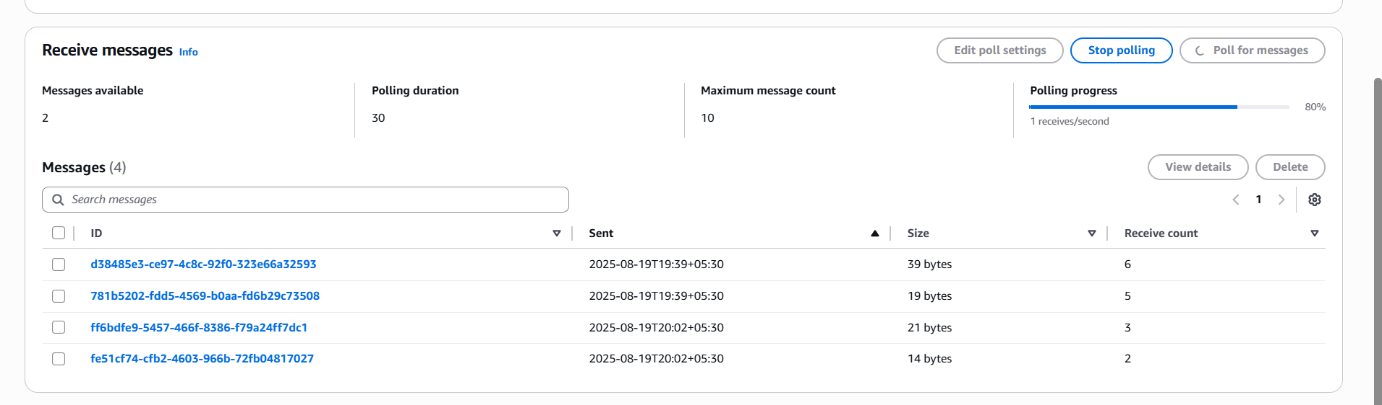

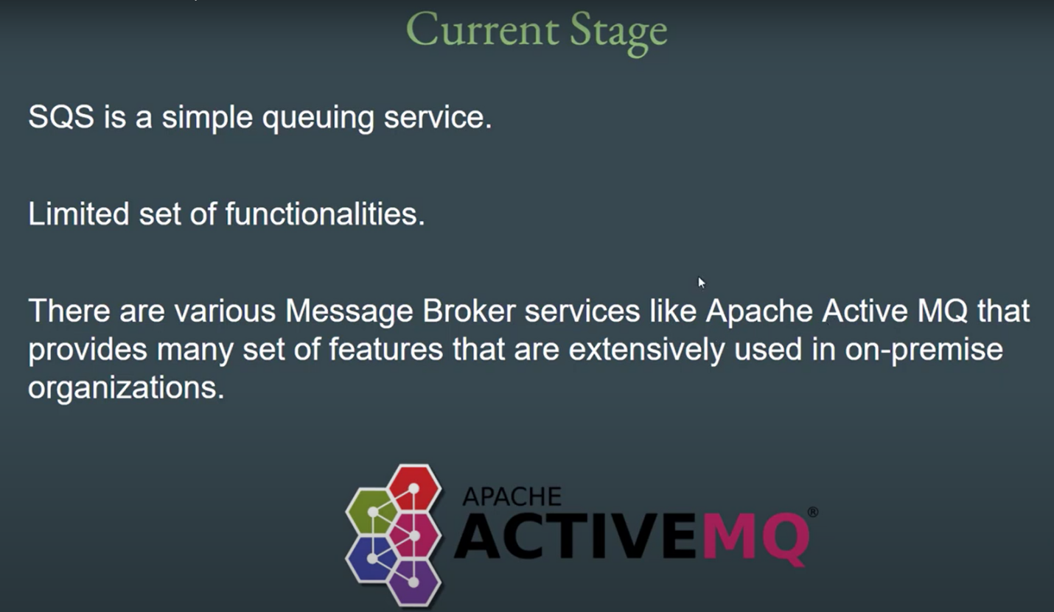
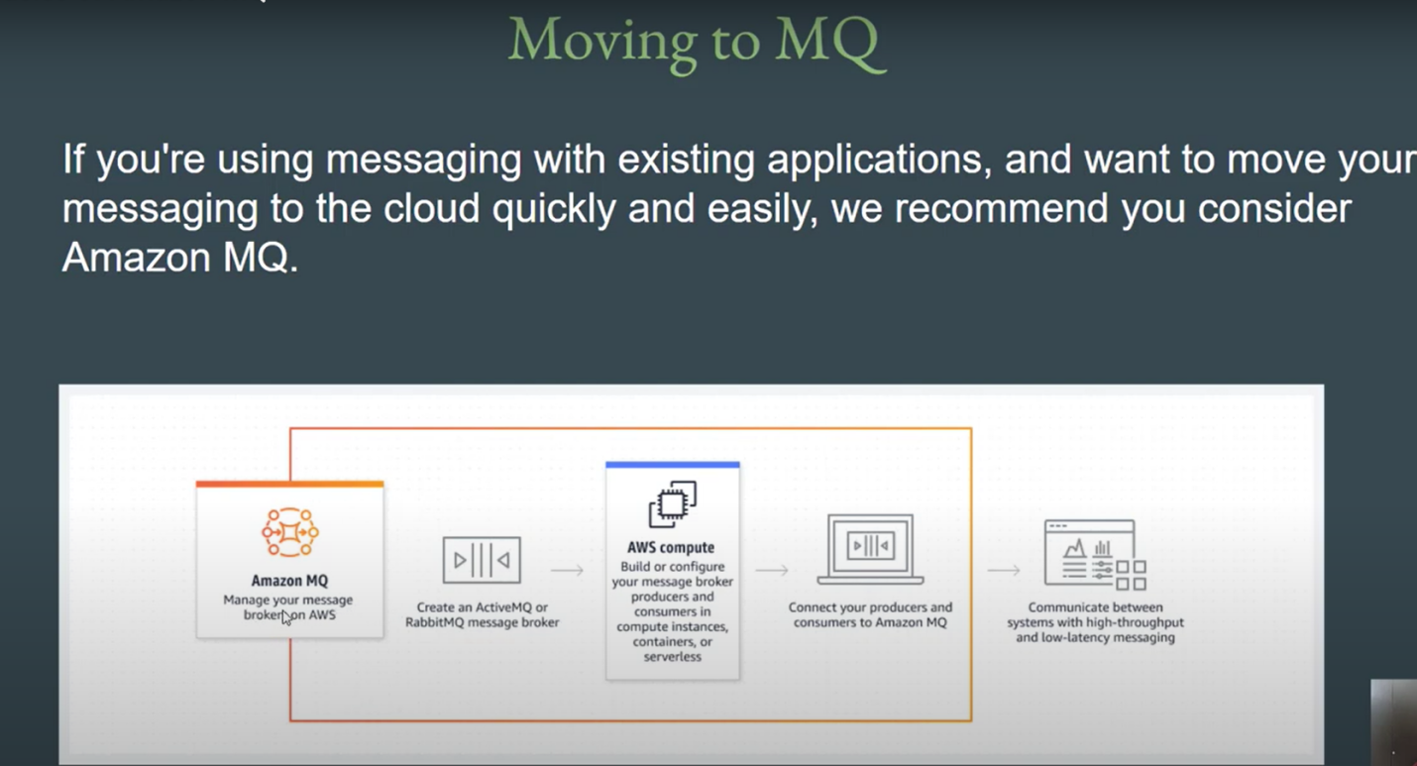
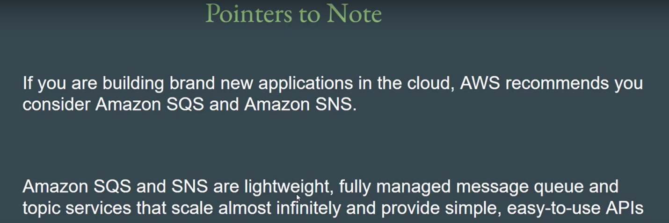
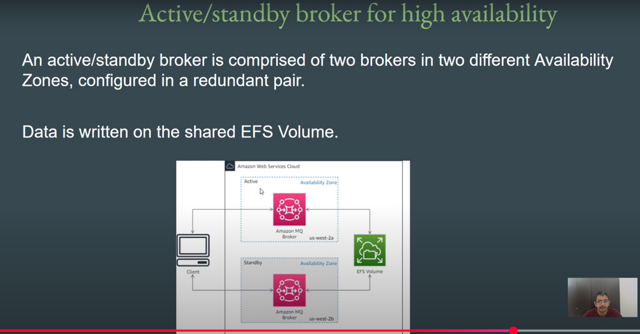
- Created a imran-mq
- 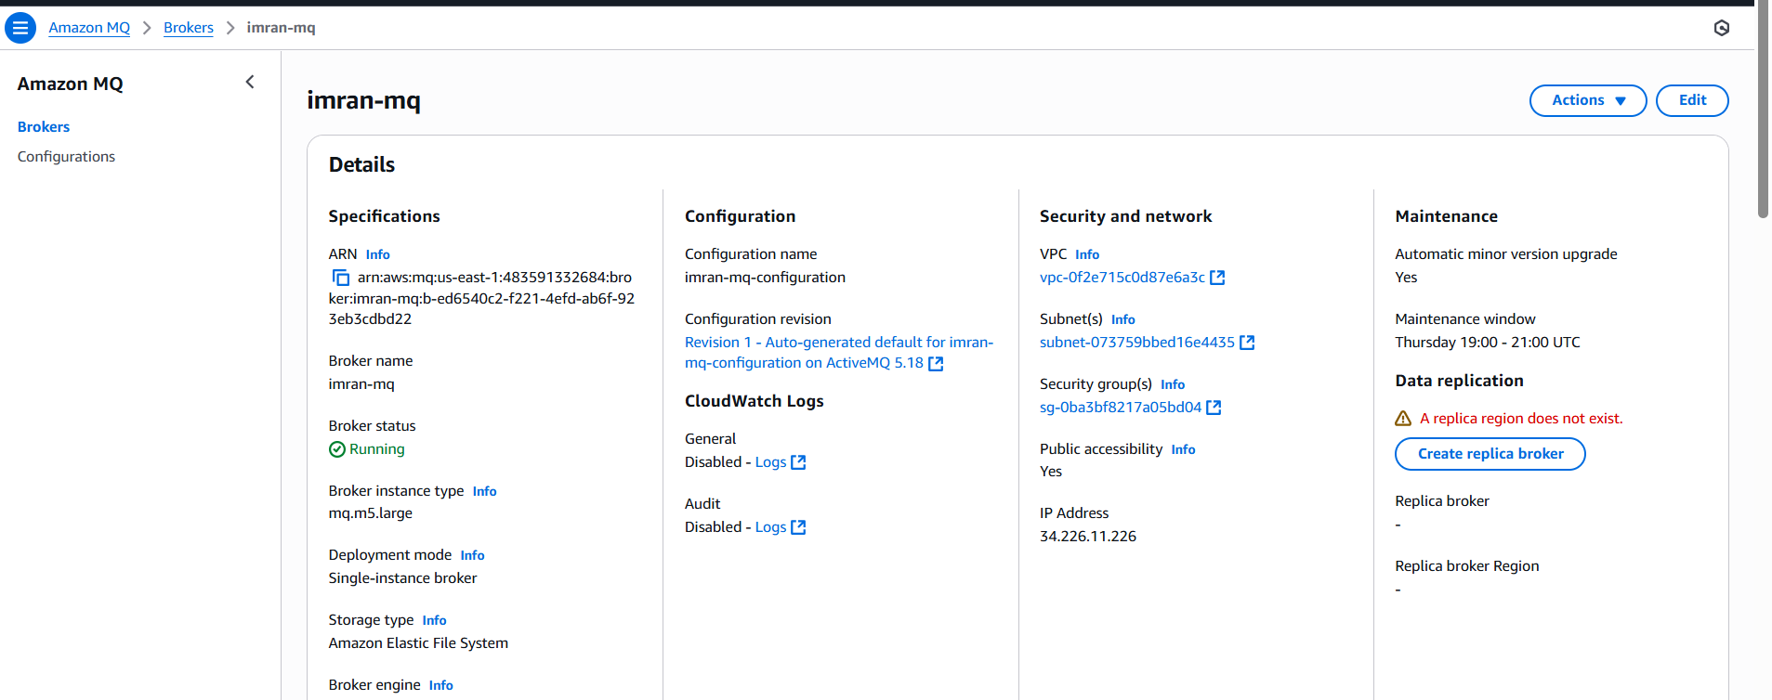
- https://b-ed6540c2-f221-4efd-ab6f-923eb3cdbd22-1.mq.us-east-1.amazonaws.com:8162
- 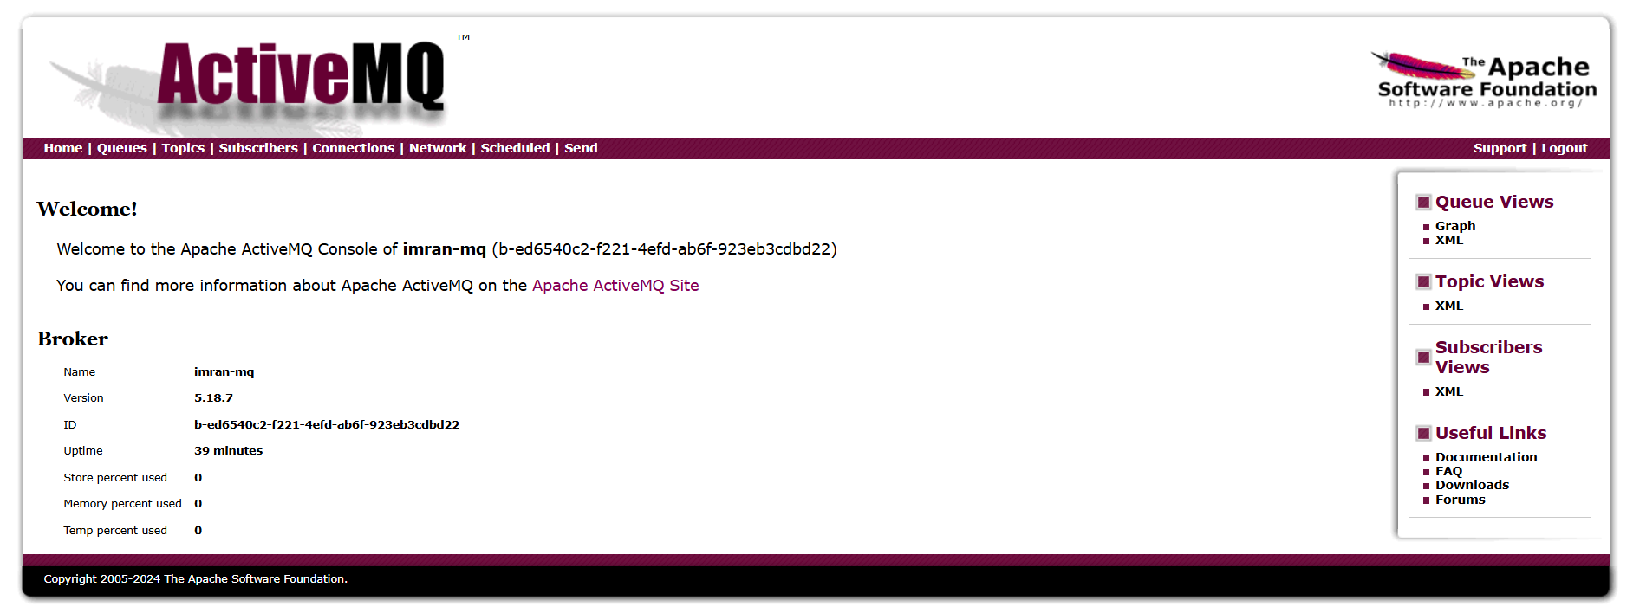
- In imran-mq created a test queue and send the message
- 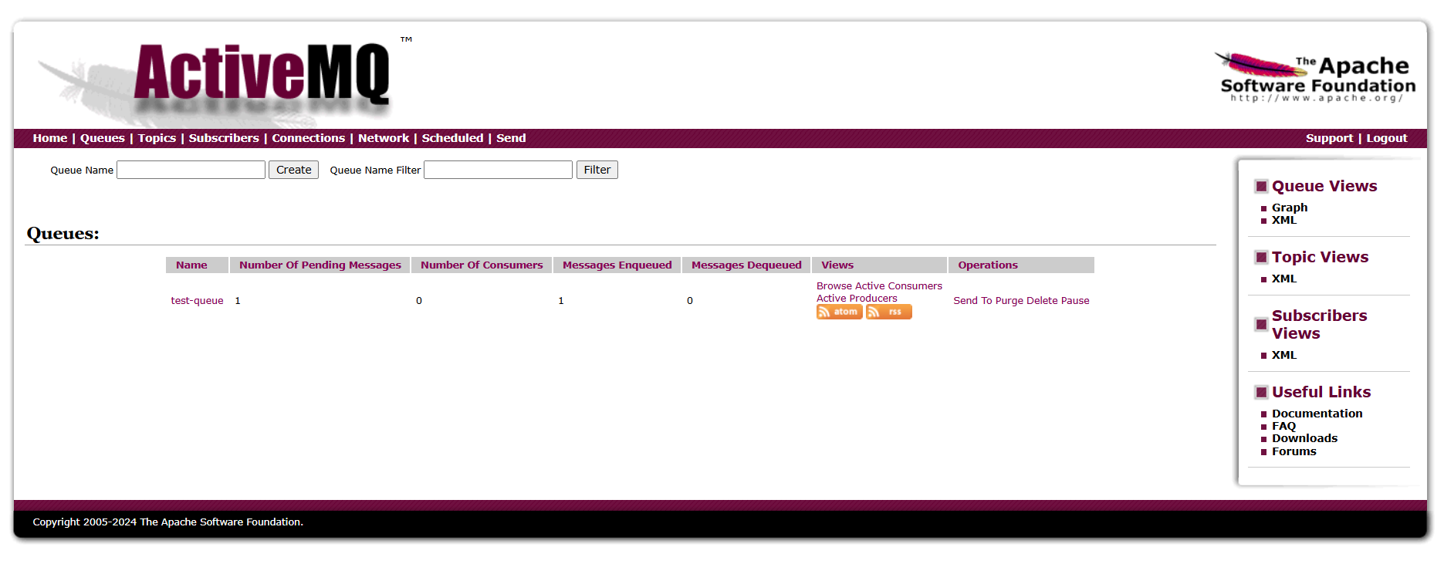
- You can find the message
- 